National Endowment for the Arts

Investment Fact Sheet

December 2022

National Endowment for the Arts Appropriations

- Each $1 in National Endowment for the Arts grant funds leverages another $9 from other public and private sources, resulting in $500 million in matching support.

- The $180 million budget of the National Endowment for the Arts (NEA) represents just 0.003% (less than four thousandths of one percent) of the federal budget.

Everyone Benefits

- The National Endowment for the Arts has an exemplary partnership with states. Forty percent of all NEA program funds—approximately $45.7 million in fiscal year 2022—is distributed through state arts agencies and regional arts organizations.

- In combination with approximately $820.8 million in state appropriations, the federal-state partnership supports more than 25,000 grants in 16,000 communities across the United States.

- Combined, NEA and state arts agency grant awards reach all 435 federal congressional districts.

- The arts reach rural areas. States use NEA and state legislative funds together to address the unique needs of rural areas. Twenty-one percent of state arts agency grants go to rural communities. Even larger proportions of grants and grant dollars go to rural areas in states with larger rural populations.

- NEA funding benefits underserved populations, such as people with disabilities, people in institutions and veterans. Thirty-six percent of activities supported by the NEA reach underserved populations.

Return on Investment

- The arts are a positive investment. The U.S. Bureau of Economic Analysis reports that arts and cultural production contributes more than $876,665 billion to the nation's economy. This equates to 4.2% of GDP, which is a greater percentage than transportation and warehousing (2.7%).
- The arts create jobs. Arts and culture support 4.6 million wage and salary workers and many more independent jobs.

- The arts help economies recover. The arts and culture sector sees robust economic growth even during economic downturns. This resilient growth supports states' economies even during recessions.

- The arts strengthen education. Research confirms that the arts cultivate young imaginations and facilitate success in school, improving emotional intelligence and enhancing students' academic achievement in multiple subject areas.

- The arts have positive health outcomes, especially for military service members. The National Endowment for the Arts' Creative Forces initiative now has clinical sites at 13 military bases and 10 community connection sites throughout the country. In 2020, Creative Forces supported approximately 23,000 encounters and treated more than 4,000 patients.

National Endowment for the Arts Funding to Iowa:
What's at Stake

- In its FY2021, the National Endowment for the Arts provided $709,635 in Partnership Agreement funds to the Iowa Arts Council. These critical funds are used in conjunction with state legislative dollars to support grants and services across the state of Iowa.

- An additional $786,800 was distributed to the Iowa Arts Council through the NEA from the 2021 American Rescue Plan (ARP) Act. These emergency funds were used to support much-needed relief grants for constituents across the state.

- NEA and state funds enabled the Iowa Arts Council not only to award 326 grants totaling $3,157,317 in its FY2022, but also to provide nongrant services to arts organizations, community groups, schools and artists. These grants and services supported access to the arts, jobs, arts education, community well-being and the cultural heritage of the state.

- The NEA also awards grants directly to arts organizations in each state. In its FY2021, the NEA made 4 direct grants totaling $130,000 in Iowa. In addition to these grants, the NEA made 5 direct grants using ARP Act funding in Iowa that totaled $900,000.

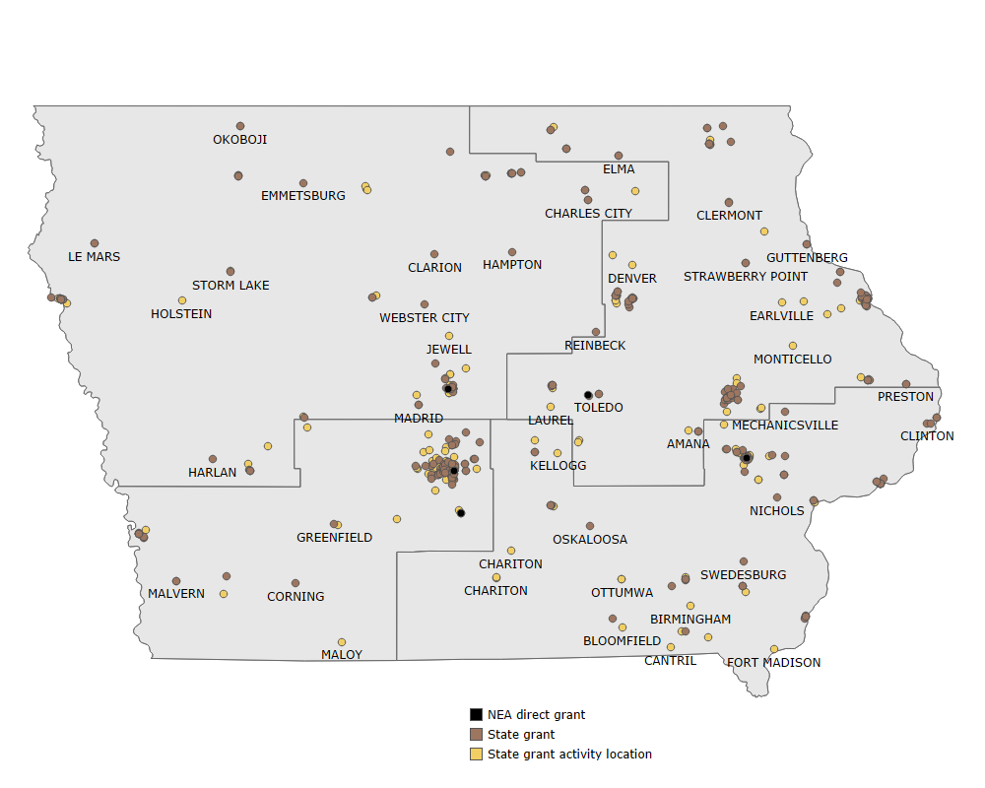
National Endowment for the Arts and Iowa Arts Council Grants, 2022

Symbols indicate at least one grant award recipient. One symbol may indicate multiple awards in densely populated areas.
Grants location data reflect current final reports from the National Endowment for the Arts (FY2021) and the state arts agency (FY2022).
Geographical boundaries represent U.S. congressional districts for the 117th United States Congress.

